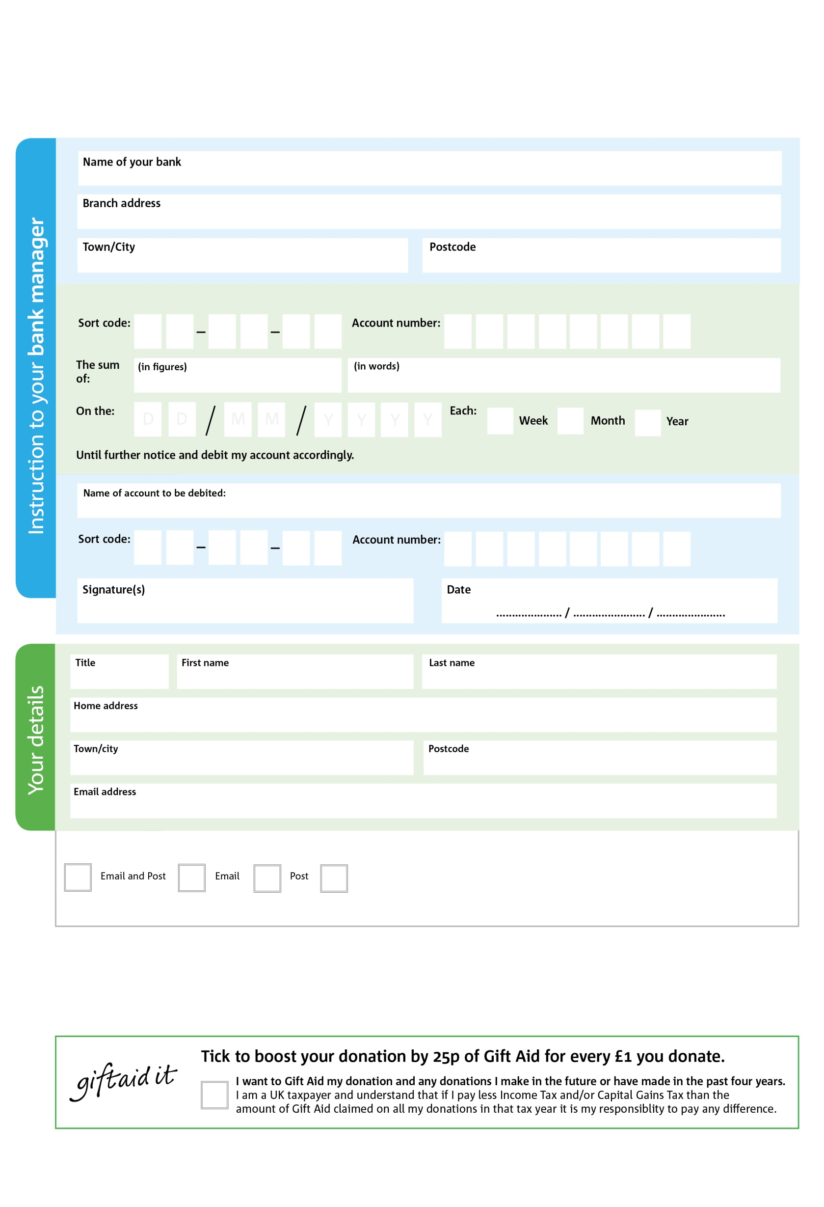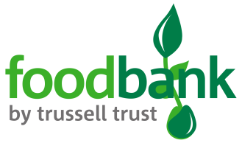

Reg. Charity No: 1128665 | Reg. in England & Wales

**Data protection**

*Stratford upon Avon Foodbank is committed to protecting your privacy and will process your personal data in accordance with current Data Protection legislation. Stratford upon Avon Foodbank collects information to keep in touch with you and supply you with information relating to our work. A full data privacy statement for financial donors is available from the foodbank on request.*

POSTAL ADDRESS: Stratford upon Avon Foodbank, Foundation House, Masons Road. Stratford upon Avon, CV37 9NF

XXXXX Road, XXXXXX, TOWN, POSTCODE

You can change your preferences any time by contacting us on 07884 418732 or emailing us at info@stratforduponavon.foodbank.org.uk

4

0

Please pay Stratford upon Avon Foodbank

**Standing Order Mandate**

**stratforduponavon.foodbank.org.uk**

8

V

3

V

5

V

2

V

4

V

1

V

2

V

9

V

**Please pass this form onto the foodbank, using the foodbank’s address at the bottom, who will save a copy for their records.   
They will then send it onto your named bank or building society.**

9

1

3

4

We would love to keep you up to date with information about Stratford upon Avon Foodbank. Please tick your preference:

I do not wish to receive future communications from Stratford upon Avon Foodbank

You can change your preferences any time by contacting us on XXXXXXXXXXX or emailing us at XXXX@XXXXXXXXXX.foodbank.org.uk

I do not wish to receive future communications from XXXXXX Foodbank