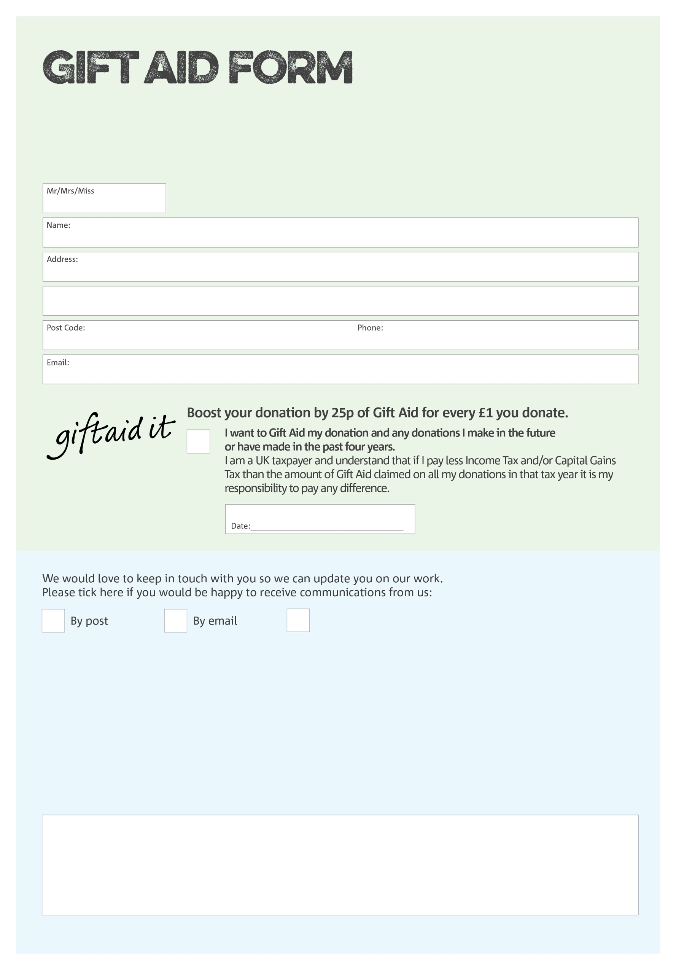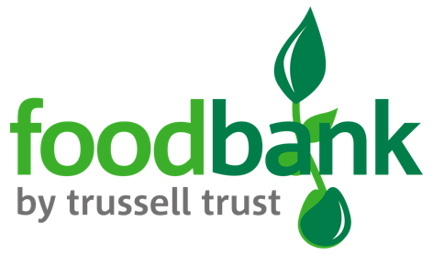

By filling in this form Stratford upon Avon Foodbank will receive an extra 25p for every £1 you give at no extra cost to you. Thank you!

Reg. Charity No: 1128665 | Reg. in England & Wales

**Data protection**

*Stratford upon Avon Foodbank is committed to protecting your privacy and will process your personal data in accordance with current Data Protection legislation. Stratford upon Avon Foodbank collects information to keep in touch with you and supply you with information relating to our work. A full data privacy statement for financial donors is available from the foodbank on request.*

POSTAL ADDRESS: Stratford upon Avon Foodbank, Foundation House, Masons Road. Stratford upon Avon, CV37 9NF

XXXXX Road, XXXXXX, TOWN, POSTCODE

I do not wish to receive future communications from Stratford upon Avon Foodbank

You can change your preferences any time by contacting us on 07884 418732 or emailing us at info@stratforduponavon.foodbank.org.uk

We would love to know why you have chosen to donate to Stratford upon Avon Foodbank. If you would like to share your motivation let us know below: